Project Management Plan
for the
VDI Data Center Project

Prepared by:
Moe Yousof

A paper submitted to the
Project Management Training Program

in partial fulfillment of the requirements for the
Project Management Certificate

offered by
Calgary Immigrant Educational Society (CIES)

Table of Contents
1. Initiating Process 5
1.1. Background 5
1.2. Business Needs 6
1.3. Project Charter Summary 7
1.4. Stakeholder Register 11
2. Planning Process 12
2.1. Integration Management 13
2.1.1. Integration Management Approach 13
2.1.2. Project Team 13
2.1.3. Manage Change 15
2.1.3.1. Project Changes 15
2.1.3.2. Contract Changes 15
2.2. Scope Management Plan 16
2.2.1. Scope Statement 16
2.2.1.1. Project Approach 17
2.2.1.2. Project Assumptions 17
2.2.2. Work Breakdown Structure (WBS) 18
2.2.3. Integration Management Approach 18
2.3. Time Management Plan 19
2.3.1. Develop Schedule 19
2.3.2. Control Schedule 19
2.4. Cost Management Plan 20
2.4.1. Estimate Cost 20
2.4.2. Control Cost 22
2.5. Quality Management Plan 23
2.5.1. Quality Assurance 23
2.5.2. Quality Control 24
2.6. Human Resources Management Plan 25
2.6.1. Roles and Responsibilities 25
2.6.2. Staffing Management 27
2.7. Communication Management Plan 28
2.7.1. Communication Matrix 28
2.8. Risk Management Plan 29
2.8.1. Risk Management Approach 29
2.8.2. Identify Risks 29
2.8.3. Risk Register 30
2.8.4. Monitor and Control Risks 30
2.9. Procurement Management Plan 31
2.9.1. Procurement Management Approach 31
2.9.2. Procurement Process 32
2.9.3. Procurement Risks 33
2.9.4. Procurement Constraints 34
2.9.5. Contract Changes 35
2.10. Stakeholder Management Plan 35
2.10.1. Manage Stakeholder Expectations 35
2.10.2. Stakeholder Relationships 36
2.10.3. Stakeholder Engagement Matrix 36
3. Executing, Monitoring and Controlling Processes 37
3.1. Performance Data Gathering 37
3.2. Performance Measurement 37
3.3. Project Status Reports 38
4. Closing Process 40
4.1. Acceptance Criteria 40
4.2. Lesson Learned 40
4.3. Contracts Closure 41
4.4. Administrative Closure 42
Appendix 43
i. Stakeholder Register 43
ii. Stakeholder Relationships 44
iii. Work Breakdown Structure (WBS) 45
iv. Schedule Gantt Chart 48
v. Risk Register 49
vi. Site Selection Criteria Checklist 50
Executive Summary
The move towards cloud computing has become prevalent in the Canadian workplace for all the benefits it provides over conventional computing. Cloud computing reduces total cost of ownership, facilitates easier access to applications and data, provides better control for administration of the IT infrastructure, and helps the environment through offering greener and more economic desktop structure by using less hardware to implement and less power to operate. Virtual Desktop Infrastructure (VDI) is implemented by the City of Calgary to move into the cloud and this requires a data center to work as its heart.

The City of Calgary is sponsoring a project to plan, design, and build the VDI Data Center. This data center will host more than 15,000 user accounts with over 10,000 virtual machine images and 2,000 Terabytes of storage medium. It will also provide access to all the applications which are used by the different business units of the City.

The new VDI-DC will also allow the storage of all VM images and user data to be consolidated and re-organized from several storage islands into one physical and logical unit. This gives the IT infrastructure of the City the scalability, performance, fault tolerance, and manageability required to meet current and future needs. The storage cluster will also eliminate the need to disrupt services when hardware upgrades are required.

The directive for this initiative was provided by the IT Planning group and the City Advisory Committee and was approved by City Council and the Executive Committee of the project on the 15th of September, 2014.

Initiating Process

Background

The IT industry if one of the fastest growing industries in Canada that is driven by the strong economy. Currently, there are 113 data centers located in 23 cities all across Canada. Calgary hosts %3.5 only of these data centers with some at their maximum capacity.

City | No. of Data Centers | % of Data Centers
Toronto | 28 | 24.8%
Montreal | 27 | 23.9%
Vancouver | 12 | 10.6%
Mississauga | 5 | 4.4%
Calgary | 4 | 3.5%
Halifax | 4 | 3.5%
Hamilton | 4 | 3.5%
Kelowna | 4 | 3.5%
Quebec | 4 | 3.5%
Edmonton | 3 | 2.7%
Winnipeg | 3 | 2.7%
Ottawa | 2 | 1.8%
Saint John | 2 | 1.8%
St. John’s | 2 | 1.8%
Barrie | 1 | 0.9%
Charlottetown | 1 | 0.9%
Kingston | 1 | 0.9%
Lethbridge | 1 | 0.9%
Nanaimo | 1 | 0.9%
Oakville | 1 | 0.9%
Saskatoon | 1 | 0.9%
Waterloo | 1 | 0.9%
Windsor | 1 | 0.9%
Total | 113 | 100.0%

Table 1.1.1 The number and percentage of data centers hosted in different Canadian cities

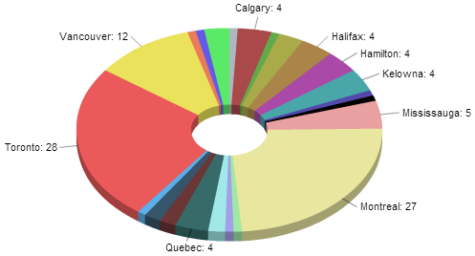

Figure 1.1.1 Pie chart showing the number of data centers in major Canadian cities

The Business Needs for the City of Calgary call for a cloud computing solution with uninterrupted response time and uncompromised service reliability. Calgary is Western Canada’s capital of corporate headquarters with a strong and growing economy. The new VDI Data Center will serve the expanding needs of the City and contribute tremendously to the IT infrastructure of the province as a whole.

Business Needs

The City of Calgary incorporates 29 Business Units with more than 14,500 employees spread out over 150 facilities. Some of the City’s Business Units are running critical services that cannot be interrupted. These business units include:

- Calgary Fire Department
- Public Safety Communications (911)
- Calgary Transit

Calgary witnesses one of the highest population growth rates across Canada and the need for the City to accommodate demands for such growth requires all of its Business Units to work efficiently and flawlessly. The IT Infrastructure of the City is a crucial component of all of its Business Units with more than 10,000 devices connected to the City’s intranet. With the decision to move to cloud computing, the need for a data center that is local and under control of the City has become evident.

Project Charter Summary

Project Title: VDI Data Center Design and Build
Project Sponsor: South Alberta Data Centers Inc. (SADC Inc.)
Project Customer: The City of Calgary
Project Manager: Moe Yousof
Document History:
Revision Number | Date of Issue | Author | Description
Version 0.9 | October 27th, 2014 | Moe Yousof | Initial Draft
Version 1.0 | November 3rd, 2014 | Moe Yousof | Executive Committee Review
Purpose and Description
The purpose of this project is to build a data center facility. It will start with the planning phase and followed by the construction phase.

The site of the data center will be provided by the City of Calgary. The site must fulfill all criteria provided in the “Site Selection Criteria Checklist” document. The design and build of the VDI Data Center will be implemented by South Alberta Data Centers Inc.

After the new data center is commissioned all current Virtual Machines (VMs) and related Data Stores will be migrated to the new centralized data center. South Alberta Data Center Inc. is contractually obligated to provide continuous service to it is clients. However, as service interruption is unavoidable, one goal of this project will be to control and minimize the interruptions of the current service when migrated to the new data center.
Deliverables and Milestones
The following is a list of the project deliverables and milestones:
- Planning
- Develop Project Management Plan
- Collect Business and Technical Requirements
- Review and Prioritize Requirements
- Prepare Workload Assessment Report
- Determine Capacity and Equipment Requirements
- Prepare Project Budget Outline and Details
- Develop Disaster Recovery Plan
- Plan and Design Civil Requirements
- Plan and Design Electrical Requirements
- Plan and Design Mechanical Requirements
- Plan and Design Networking Requirements
- Plan and Design IT Requirements
- Develop Migration Strategy Plan
- Procurement
- RFP Development and Initiation
- RFP Submission and Evaluation
- Subcontractors Assignment
- Site Preparation
- Inspect Site
- Complete Necessary Demolition
- Construction
- Complete Civil Construction
- Complete Electrical Installation
- Complete Mechanical Installation
- Complete Networking Installation
- Complete IT Installation
- Testing and Commissioning
- Test and Commission Facility
- Perform Acceptance Test
- VMs and Data Stores Migration
- Execute Migration Plan
- Run Benchmark Tests to Evaluate Migration

Funding and Budget
The project is wholly funded by the City of Calgary. The total budget approved for the project is $2.1 Million.

Budget outline and details will be prepared and approved in a separate document.
Timeframe and Schedule
The official start date is November 1st, 2015. The project is estimated to be completed in 10 months and the end date is August 31st, 2015.

A detailed schedule will be developed separately.
Dependencies
Dependencies for this project include:
- The City of Calgary IT Services
- The City of Calgary Corporate Security
- The City of Calgary Corporate Assets
Constraints
Constraints for this project include:
- The project site needs to be handed over to the Project Team before December 1st, 2014
Risks
The project will have a Management Consultant Team that will provide quality control and be in charge of quality assurance. This team will continually evaluate and assess project risks and make sure all project requirements and specifications are met as defined in the project plan.

A detailed risk register will be developed separately.
Stakeholders
A registry of all internal and external stakeholders will be prepared as a separate document and will include vendors and subcontractors selected through the procurement process.

Communication Plan
A meeting will be held on the first business day of every week throughout the project to discuss project progress and any issues related to it that require a stakeholder attention. These meetings will be attended by the members of the Executive Committee and a representative from each subcontractor. Other stakeholders will be invited to attend meetings as needed or required.

An email will be sent out bi-weekly to all stakeholders to inform about the progress of the project. A detailed communication plan will be prepared as a separate document.
Governance and Decision Rights
Project leadership expects project level decisions to be made and project activities to be completed at the lowest possible level within the project organizational structure. Issues, regardless of where they come from or how they surface, will be reported to the appropriate team lead to be logged and managed and to be escalated as required.

Risks affecting the project can be suggested and reported by anyone, but all suggestions require Project Manager approval to officially open a project level risk.

Issues, risks, and change management will follow standard processes that will be described in separate project documents. However, these items will be escalated to the Executive Committee or Project Sponsor for action by the Project Manager depending on their severity and time sensitivity.

Any email or voice message sent to the Executive Committee Chairman or the Executive Sponsor that requires a decision to be made will specify a decision date or time within reasonable limits. If the Project Manager received no answer from the Executive Committee Chairman or the Executive Sponsor by the specified date or time this will imply initial approval on decision and the project may then continue. If the Executive Committee Chairman or the Executive Sponsor does not approve the decision or requires further clarification then they must contact the Project Manager within the specified time to avoid any delay in schedule.

Approval
The project charter has been reviewed and accepted as written. Approval is given to move forward with the project as outlined in this document.

_____________________________ _____________________________
Celine Dion Date
Executive Sponsor
South Alberta Data Centers Inc.

_____________________________ _____________________________
Moe Yousof Date
Project Manager
South Alberta Data Centers Inc.

End of project charter summary

Stakeholder Register

Please refer to section i. of the Appendix.

Planning Process

Planning to build a data center is a major challenge for many IT departments due to the need for an exhaustive level of communication among the various stakeholders of the facility. With their unique structure, small changes in data center plans can have major cost consequences or create unexpected surprises for some Stakeholders. The planning process can consume a significant part of the calendar time of a project, and it is common that changes occur late in the planning phase causing re-work that commonly results in a significant delay in project completion.

The City of Calgary is recruiting SADC Inc. because of the accumulated experience it has to offer in planning, designing, and building data centers. SADC Inc. will carry out the project management of the VDI Data Center with a great focus on the unique Business Needs of the City’s Business Units.

Business Needs
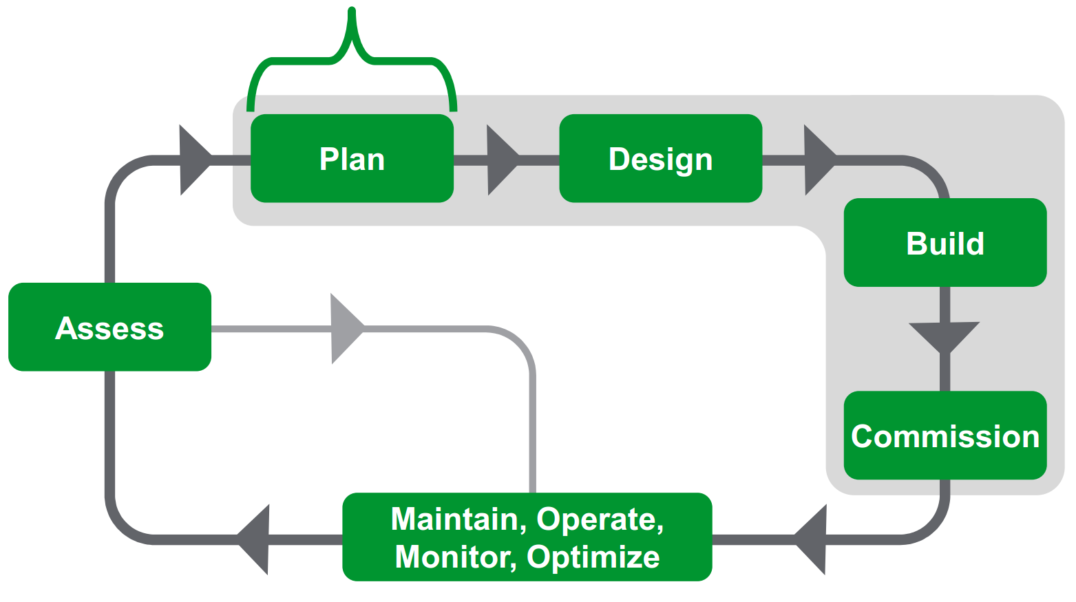
Figure 2.1 Business Needs are an important input to the planning process of a data center project lifecycle

Integration Management

The Project Manager is responsible for effective project integration management as the success of this project is highly dependent on it. Integration management also helps to maintain satisfaction of the project Stakeholders throughout the project lifecycle and limits the chance of conflict to rise.

Integration Management Approach

This project starts with the development of the project charter to provide a formal authorization of the project through proper documentation. The charter is developed by the Project Manager and states the initial requirements that fulfill the Business Needs of the City and satisfy the project Stakeholders. After the project charter is signed by both the Project Manager and the Executive Sponsor, the Project Manager will use the project charter for organising the required resources to ensure successful completion of the project. He will also determine the external and internal environment that can influence the project, and he will start to prepare detailed documentation of the project management plan. The plan is an important tool for the Project Manager to understand the project and execute it properly. It will guide the Project Manager and Project Team for directing and managing the execution of the project. The major role of the Project Manager is to manage project execution, monitor and control project work, perform integrated change control, and eventually complete the project and hand it over to the City of Calgary.

Project Team

Celine Dion, the PMO Head of South Alberta Data Centers Inc. (SADC Inc.), is the Executive Sponsor of the VDI Data Center Design and Build project. Moe Yousof is the Project Manager, Martin Short is the Project Analysts Head, Keanu Reeves is the Designing Engineers Head, and Ryan Reynolds is the Technicians Head. The team will also have a Contract Officer, Planner, Scheduler, Cost Controller, Coordinator, Civil Engineering Designer, Electrical Engineering Designer, Mechanical Engineering Designer, Networking Designer, IT Designer, Construction Specialist, Networking Technician, and IT Technicians. The hierarchy and relationship between Project Team members is shown in the following diagram:

Figure 2.1.2.1 The VDI-DC Project Team hierarchy and relationships diagram

Manage Change

The project will have two approaches to deal with changes, one for project changes, and another for contract changes.

Project Changes

These are changes in activities that happen within the Project Team and must be incorporated to allow the project to proceed on schedule and to provide a fully functional facility. The change may be generated as a result of change in a site condition, errors in a design, or a change in the equipment specifications. Funding for these changes is covered by the project contingency and managed by the Project Manager. These changes will receive top priority for implementation. Approval authority for these changes rests with the Project Sponsor and must be conducted through the Project Manager.

Contract Changes

These changes generally are change requests to the contracts initiated by the Project Sponsor. Such changes after a contract is awarded are normally very expensive and may delay completion of the project. The Project Team will maintain a priority list of deferred changes with preliminary cost estimates. All requests for these changes will be submitted to the Contract Officer. When required, the Project Manager will provide a written scope of work, preliminary cost estimate, and impact statement for the proposed change. The Project Manager will review the proposed change with the Contract Officer to determine whether the change is out of project scope, exceeds available funds, should be deferred, or is going to be rejected.

Scope Management Plan

Scope Statement

The scope for this project is defined through a comprehensive requirements collection process. A thorough analysis is performed on the business requirements of all the Business Units of the City. The project description and deliverables are developed based on the outputs of the requirements collection process that are prepared by subject matter experts from both the City and SADC Inc. This process of expert judgment provides feedback on the most effective ways to determine the Business Needs of all the Business Units of the City. The following Project Scope table is one of the outputs of the requirements collection process:

In Scope | Out of Scope
- Collect all business and technical requirements that will be used to plan, design, build, and operate the VDI-DC.  - Prepare the Workload Assessment Report  - Develop the disaster recovery plan for the VDI-DC. (Note: Implementing the disaster recovery plan will be a separate project)  - Inspect and prepare the site that will host the VDI-DC and make sure it complies with the site selection criteria that are provided to the City.  - Prepare all the designs of the VDI-DC that adheres to the business and technical requirements in terms of performance, availability, stability, and data protection.  - Prepare designs such that the facility is based on a scalable hardware infrastructure to supports future expansion of the capacity of the data center.  - Provide and implement the civil, electrical, mechanical, networking, and IT components that form the foundations of the VDI-DC.  - Test and commission the VDI-DC.  - Migrate systems, applications and other services (physical and virtual) running on other data centers into the VDI-DC. | - Relocating or moving any equipment or furniture provided by the City to the site of the VDI-DC.  - Planning, Designing or building a data center that will be used for any other purpose besides the VDI (Virtual Desktop Infrastructure) needs of the Business Unites of the City.  - Training for staff that will be operating the facility.  - Developing some or all of the operational processes that will be used to operate the facility.

Table 2.2.1.1 The In Scope and Out of Scope table

Project Approach

The approach used for this project is outlined as follow:

- South Alberta Data Center Inc. (SADC Inc.) is in charge of the management and coordination of all activities and tasks of the project. SADC Inc. will be responsible for:
  - Developing and maintaining the overall project plan and schedule.
  - Documenting and managing issues and risks among all teams.
  - Establishing project management templates and repeatable processes to manage the VDI-DC project.
  - Establishing standard migration strategies, templates, and repeatable processes to migrate exciting services.
  - Make the Migration process as efficient and low risk as possible.
- SADC Inc. is in charge of developing the VDI-CD disaster recovery plan.
- SADC Inc. is in charge of the VDI-DC designing and engineering.
- SADC Inc. is in charge of overseeing the parts of the VDI-DC construction that will be conducted by selected vendors and subcontractors.
- SADC Inc. is coordinating with the IT Services of the City of Calgary for monitoring schedule and budget, resolving issues and risks, and planning and executing the migration strategy of existing VMs and Data Stores.
- Migration to the VDI-DC is using a low risk approach to avoid unplanned outages.

Project Assumptions

Assumptions that this project is based on are as follows:

- The design and build of the VDI Data Center will be implemented by South Alberta Data Centers Inc. as the general contractor of the project.
- The site of the data center is provided by the City of Calgary. The site will fulfill all criteria provided in the “Site Selection Criteria Checklist” document. Please refer to section vi. of the Appendix for the checklist.
- Current network infrastructure is sufficient to meet the needs of the centralized VDI Data Center.
- The City of Calgary IT Services resources and staff are available when and as they are needed.
- Planning, design, server procurement and installation, and management consultancy of the project is provided directly by SADC Inc.
- Subcontractors are selected to implement the civil, electrical, and mechanical, components of the project.
- SADC Inc. is directly implementing the networking and IT components of the project.
- Budget is available on time and as scheduled and approved.
- The scope of the project is limited to that described in this section of the project plan.

Work Breakdown Structure (WBS)

Please refer to section iii. of the Appendix.

Integration Management Approach

For this project, scope management responsibility will be solely on the Project Manager. The scope for this project is defined by the scope statement and the work breakdown structure (WBS). The Project Manager and the Executive Sponsor will establish and approve documentation for measuring the Project Scope which includes deliverable quality checklists and work performance measurements. Proposed scope changes may be initiated by any member of the Project Team. All change requests will be submitted to the Project Manager who will then evaluate the requested scope change. Upon acceptance of the scope change request, the Project Manager will submit the scope change request to the Executive Committee for approval.

Time Management Plan

Develop Schedule

The overall duration of the project is estimated to be 10 months, with a start date of November 1st, 2014 and end date of August 31st, 2015.

Activity sequencing is used to determine the order of work packages and to assign relationships between project activities. Activity duration estimating is used to calculate the number of work periods required for completing work packages.

Please refer to section iv. of the Appendix for the schedule Gantt chart.

Control Schedule

Once a preliminary schedule has been developed using Gantter.com, it will be reviewed by the Project Team and other resources tentatively assigned to project tasks. The Project Team and resources must agree to the proposed work package assignments, durations, and schedule before approving it.

The Project Schedule will be reviewed and updated on a bi-weekly basis or as necessary, with actual start, actual finish, and completion percentages provided by task owners. The Project Manager is responsible for holding a bi-weekly schedule update and review meetings (status meetings), determining impacts of schedule variances, submitting schedule change requests, and reporting schedule status in accordance with the communications plan of the project. The Project Team is responsible for participating in the bi-weekly status meetings, communicating any changes to actual start and actual finish dates to the Project Manager, and participating in schedule variance resolution activities whenever needed. The Executive Sponsor will maintain awareness of the project schedule status, and she will review and approve any schedule change requests submitted by the Project Manager. A variance of ±0.1 in the schedule performance index (SPI) will change the status of the schedule as indicated in the following table:

SPI between 0.9 and 1.1 | Green
SPI between 0.8 and 0.9 or between 1.1 and 1.2 | Yellow
SPI less than 0.8 or greater than 1.2 | Red

Table 2.3.2.1 The change of the schedule status in accordance with the current project SPI

Cost Management Plan

The Project Manager will be responsible for managing and reporting on the project budget throughout the lifetime of the project. During the bi-weekly project status meetings, the Project Manager will meet with the Executive Sponsor and Executive Committee Chairman to present and review the project budget performance for the preceding two weeks. Performance will be measured using project earned value (EV). The Project Manager is accountable for cost deviations and responsible for presenting the Executive Sponsor with options for getting the project back on budget. The Executive Sponsor has the authority to make changes to the project to bring it back within budget.

Estimate Cost

The estimated total cost of this project is $2,101,470 and that is the planned project budget. The project budget is detailed in the following table:

VDI Data Center Project Budget
Planning
Description | Man-Hour Labor | Cost/  Man-Hour | Total Labor Cost | Total Material Cost | Total Cost
Requirements | 200 Hours | $40 | $8,000 |  | $8,000
Design and Engineering - Civil | 160 Hours | $75 | $12,000 |  | $12,000
Design and Engineering - Electrical | 160 Hours | $75 | $12,000 |  | $12,000
Design and Engineering - Mechanical | 160 Hours | $75 | $12,000 |  | $12,000
Design and Engineering - Networking | 120 Hours | $60 | $7,200 |  | $7,200
Design and Engineering - IT | 80 Hours | $60 | $4,800 |  | $4,800
Disaster Recovery Plan | 80 Hours | $50 | $4,000 |  | $4,000
Planning Total | 960 Hours |  | $60,000 | $0 | $60,000
Procurement
Description | Man-Hour Labor | Cost/  Man-Hour | Total Labor Cost | Total Material Cost | Total Cost
RFP Development and Initiation | 80 Hours | $35 | $2,800 |  | $2,800
RFP Submission and Evaluation | 80 Hours | $35 | $2,800 |  | $2,800
Subcontractors Assignment | 80 Hours | $35 | $2,800 |  | $2,800
Procurement Total | 240 Hours |  | $8,400 | $0 | $8,400
Construction
Description | Man-Hour Labor | Cost/  Man-Hour | Total Labor Cost | Total Contract or Equipment Cost | Total Cost
Site Preparation | 40 Hours | $25 | $1,000 | $5,000 | $6,000
Site Construction - Civil | SUBCONTRACTED |  |  | $180,000 | $180,000
Site Construction - Electrical | SUBCONTRACTED |  |  | $1,000,000 | $1,000,000
Site Construction - Mechanical | SUBCONTRACTED |  |  | $250,000 | $250,000
Site Construction - Networking | 120 Hours | $35 | $4,200 | $25,000 | $29,200
Site Construction - IT | 160 Hours | $35 | $5,600 | $200,000 | $205,600
Construction Total | 320 Hours |  | $10,800 | $1,660,000 | $1,670,800
Testing and Commissioning
Description | Man-Hour Labor | Cost/  Man-Hour | Total Labor Cost | Total Material Cost | Total Cost
Data Center Testing | 120 Hours | $50 | $6,000 | $2,000 | $8,000
Acceptance Testing | 40 Hours | $50 | $2,000 |  | $2,000
Testing and Commissioning Total | 160 Hours |  | $8,000 | $2,000 | $10,000
Migration
Description | Man-Hour Labor | Cost/  Man-Hour | Total Labor Cost | Total Material Cost | Total Cost
Prepare Migration Plan | 40 Hours | $50 | $2,000 |  | $2,000
Execute Migration | 280 Hours | $35 | $9,800 |  | $9,800
Migration Total | 320 Hours |  | $11,800 | $0 | $11,800
Management
Description | Man-Hour Labor | Cost/  Man-Hour | Total Labor Cost | Total Material Cost | Total Cost
Determine Member of Management Consultant Team | 40 Hours | $50 | $2,000 |  | $2,000
Project Management | 1720 Hours | $120 | $206,400 |  | $206,400
Project Coordination | 800 Hours | $35 | $28,000 |  | $28,000
Prepare Acceptance Report | 80 Hours | $50 | $4,000 |  | $4,000
Management Total | 2640 Hours |  | $236,400 | $0 | $240,400
Project Subtotal |  |  |  |  | $2,001,400
Project Total
Description | Man-Hour Labor |  | Total Labor Cost | Total Contract, Equipment, or Material Cost | Total Cost
Project Contingency (5%) |  |  |  |  | $100,070
Project Total | 4640 Hours |  | $335,400 | $1,662,000 | $2,101,470

Table 2.4.1.1 The project budget

Control Cost

Performance of the project will be measured using earned value management. The following four earned value matrices will be used to measure the Project cost performance:

- Schedule Variance (SV)
- Cost Variance (CV)
- Schedule Performance Index (SPI)
- Cost Performance Index (CPI)

A variance of ±0.1 in the cost performance index (CPI) will change the status of the cost to cautionary. If the CPI has a variance of between 0.1 and 0.2 the Project Manager must report the reason for the exception to the Project Sponsor. If the CPI has a variance of greater than 0.2 the Project Manager must report the reason for the exception and provide a detailed corrective plan to bring the project performance back to acceptable levels.

Quality Management Plan

Quality Assurance

Quality assurance is the responsibility of the Project Manager. Prior to substantial completion and final acceptance of the VDI-DC, periodic conformance inspections will be conducted on a department-by-department basis or on a functional basis by the Project Manager. The purpose of these conformance inspections is to minimize delays and insure efficient construction of the facility. Subcontractors should correct any deficiencies identified during these visits before the final acceptance is scheduled. The following metrics will be used on the project:

- Completion and documentation of all quality review processes.
- 100% compliance with Data Centers standard ANSI/TIA-942-10 Tier 3 of the American National Standards Institute (ANSI)
- 100% compliance with Flood Resistant Design and Construction standard ASCE/SEI 24-05 of the American Society of Civil Engineers (ASCE)
- 100% compliance with Codes of the American Society for Testing and Materials (ASTM)
- 100% compliance with Standards of the Canadian Standards Association (CSA)
- Written acceptance by the Project Sponsor

Quality Control

The Project Manager will provide detailed feedback to the Project Sponsor concerning the audit and review results as defined in the communication plan. He also will use the following checkpoints to monitor the project quality:

- Progress Reviews: Progress documents should be reviewed by the Project Team on regular basis.
- General Construction Inspections: The Construction Specialist will be dedicated full time on this project for construction inspection and coordination. Members of the Project Team will make periodic site visits to observe compliance and conformance.
- Equipment Testing: This testing will be done during installation of equipment. Testing will be in accordance with the contract documents, including electrical equipment, mechanical equipment, networking equipment, servers, and storage media.
- Standard Compliance: The Management Consultant Team will review all designs and perform required inspections of the construction and equipment installation as work progresses. This team will assess designs and inspect the construction and equipment specifications and installation to assure 100% compliance with standards of the American National Standards Institute (ANSI), the American Society of Civil Engineers (ASCE), the American Society for Testing and Materials Codes (ASTM), and the Canadian Standards Association (CSA).
- Final Inspections: Parties included in the key final inspections will include a client representative as well as the Executive Sponsor, Project Manager, Designing Engineers Head, Technicians Head, Construction Specialist, and all appropriate Project Team members. Additional participants may include of other subcontractors representatives.
- One Year Warranty Inspection: This inspection will be scheduled with the subcontractors 11 months after commission of the Data Center.

Human Resources Management Plan

Roles and Responsibilities

Role | Major Responsibilities
Executive Committee Chairman | - Representative of the client  - Head of the Executive Committee that is responsible for final approvals of all project stages
Project Sponsor | - Make decisions on key project issues
Executive Sponsor | - Representative of the sponsor  - Representative of the client when not available  - Primary point of contact representing user requirements  - Support Project Manager in coordinating and validating user requirements and requests for changes (change orders)  - Attend all design meetings, review meetings, procurement activities and meetings, Executive Committee meetings, and final approval meetings
Project Manager | - Prepare Project Management Plan  - Ensure project is managed properly to achieve project goals and successfully complete deliverables  - Mentor and coach Project Team members  - Coordinate between different teams and stakeholders  - Forecast and prevent issues before they develop and resolve any existing issues and disputes  - Negotiate change orders and process them  - Attend all meetings related to project
Admin Assistant | - Develop, prepare, and distributing reports  - Assist in all administrative matters and office work related to project  - Support Project Team  - Ensure office and staff follow established procedures including employee orientation and training  - Distribute mail across Project Team members  - Coordinate vehicle uses in project activities
Project Analysts Head | - Lead team that consists of Planner, Scheduler, Cost Controller, and Coordinator  - Responsible, with his group, for project documentation, performance measuring, project status reporting, and schedule analysis and reporting  - Responsible with his team for risk identification and analysis  - Responsible with his team for budget reporting and payments  - Coordinate with Management Consultant Team to ensure conformance to all project requirements and specifications and compliance with all project quality standards  - Ensure compliance with provincial and federal laws and regulations
Designing Engineers Head | - Coordinate with Project Team and other stakeholders to identify project requirements and specifications  - Lead a team of Design Engineers responsible for site civil, electrical, mechanical, networking, and IT plans and designs based on project requirements and specifications  - Provide cost estimates  - Performs regular site visits  - Support Management Consultant Team for quality audits  - Ensure compliance with provincial and federal laws and regulations as well as compliance with environmental and safety regulations
Technicians Head | - Lead a team of Technicians responsible for networking and IT equipment installations as well as supporting vendors and subcontractors  - Coordinates project activities at site  - Monitor progress of construction and equipment installation to ensure conformance to all project requirements and specifications and compliance with all project quality standards  - Support Management Consultant Team for quality audits  - Ensure compliance with provincial and federal laws and regulations as well as compliance with environmental and safety regulations
Contract Officer | - Representative of Contracts and Purchasing department  - Responsible for all contractual obligations  - Attend all procurement activities and meetings and conduct RFP process  - Coordinate with Project Analysts Head to ensure conformance to all project requirements and specifications and compliance with all project quality standards  - Ensure compliance with provincial and federal laws and regulations as well as compliance with environmental and safety regulations

Staffing Management

For activities that are not subcontracted, the Project Team members will consist entirely of internal resources. The Project Manager will negotiate with functional and department managers in order to identify and assign resources in accordance with the project organizational structure. All resources must be approved by the appropriate functional or department manager before the resource may begin any work on this project.

The Project Manager will review work activities assigned to each team member at the onset of the project and communicate all expectations of work to be performed to them. The Project Manager will evaluate the performance of each team member throughout the project and determine how effectively they are completing their assigned work. Prior to releasing project resources, the Project Manager will meet with the appropriate functional manager and provide feedback on performance of each team member on the project. The functional managers will then perform a formal performance review of each team member. Although the scope of this project does not allow for ample time to provide cross-training or potential project specific rewards, there are several planned recognition and reward items for the employees of SADC Inc.

Communication Management Plan

Communication Matrix

What  (Content) | To Whom  (Stakeholder) | When  (How Often) | How  (Communication Method) | By Who  (Provider)
Project Progress | - Project Team  - Project Sponsor  - Executive Committee | Weekly | - Progress Meeting  - Progress Report | - Project Manager  - Project Analysts Head
Project Status | - Project Manager  - Executive Sponsor | Bi-weekly | - Status Meeting | - Project Team
Project Deliverables Review | - Project Analysts Head  - Planner  - Scheduler  - Cost Controller  - Coordinator | End of each project phase | - Review Meeting | - Project Manager
Contract Compliance | - Project Manager  - Contract Officer | Twice a week  (During Construction Phase) | - Contractors Meeting | - Project Team  - Civil Subcontractor  - Electrical Subcontractor  - Mechanical Subcontractor
Project Risks and Issues | - Project Team | As needed | - Risk Register  - Issue Log | - Project Team
Project Changes | - Project Sponsor  - Executive Committee | As needed | - Change Request Form  - Change Order Form | - Project Manager
Notifications and Updates | - Stakeholders | Bi-weekly | - Email  - Newsletter | - Executive Committee
Public Input | - Public | As needed | - Public Meeting | - Executive Committee

Risk Management Plan

This section defines how risk management will be structured and performed on the project. The Project Team will use the Risk Register to document project risks, including their definition, category, probability of occurrence, and potential impact.

Risk Management Approach

The approach taken to manage risks for this project includes a methodical process by which the Project Team identifies, scores, and ranks the various risks. The most likely and highest impact risks should be added to the project schedule to ensure that the assigned Risk Manager take the necessary steps to implement the mitigation response at the appropriate time during the schedule. Upon the completion of the project, during the closing process, the Project Manager will analyze each risk as well as the risk management plan and its processes. Based on this analysis, the Project Manager will identify any improvements that can be made to the risk management plan and its processes for future projects. These improvements will be captured as part of the lessons learned knowledge base.

Identify Risks

The following methods are used by the Project Manager to identify the risks associated with this project:

- Expert Interview: Two expert interviews were held for this project. The interviews revealed several risks which were then mitigated by making changes to the Project Plan. The remaining risks are included in the risk register.
- Risk Assessment Meeting: Risk assessment meetings are held with key Project Team members and other Stakeholders. The risks identified during these meetings were added to the project plan and risk register.
- Review of Similar Projects: The project team reviewed the history of similar projects completed by SADC Inc. in order to determine the most common risks and the strategies used to mitigate those risks.

Risk Register

Please refer to section v. of the Appendix.

Monitor and Control Risks

The Project Manager will maintain and update the risk register document. Risks that the team has identified as high risk will be monitored weekly by the Project Manager. All risks will be reviewed bi-weekly at the project status meetings and with the Project Sponsors. At the end of the project, risks will be reviewed and added to the lessons learned knowledge base.

The most likely and greatest impact risks should be added to the project plan to ensure that they are monitored during the time when project is exposed to each risk. During the bi-weekly project status meetings, the Project Manager will discuss the status of all risks. However, only risks which fall in the current time period will be discussed in detail. Risk monitoring will be a continuous process throughout the life of this project. As risks approach on the project schedule, the Project Manager will ensure that the appropriate team member provides the necessary status updates which include the risk status, identification of trigger conditions, and the documentation of the results of the risk response.

Procurement Management Plan

The procurement management plan sets the procurement framework for this project. It will serve as a guide for managing procurement throughout the life of the project and will be updated as acquisition needs change. This plan identifies and defines the items to be procured, the types of contracts to be used in support of this project, the process used to approve proposals, and criteria used throughout this process.

Procurement Management Approach

The Project Manager is ultimately responsible for managing vendors and subcontractors. In order to ensure the timely delivery and high quality of products from venders and subcontractors, the Project Manager will meet twice a week with each vendor and subcontractor alongside with the Contract Officer as the representative of the Contract and Purchasing department to discuss the progress for each procured item. The meetings can be in person or by teleconference. The purpose of these meetings will be to review all documented specifications for each item as well as to review the quality test findings. This forum will provide an opportunity to review the development of each item or service provided in order to ensure conformance to all project requirements and specifications and compliance with all project quality standards. It also serves as an opportunity to ask questions or modify contracts or requirements ahead of time in order to prevent delays in items delivery or project schedule. The Project Manager will be responsible for scheduling these meetings during the construction phase of the project until site construction and equipment installation is complete and approved by the Executive Committee.

Procurement Process

All items and services to be procured for this project will be solicited under firm-fixed price contracts. Project procurement will follow the following steps:

- Step 1: The Project Team will work with representatives of all the Business Units of the City of Calgary to gather the business requirements and determine the Business Needs. The output of these sessions and meetings result into a comprehensive document consisting of the project requirements and specifications. The Executive Committee of the project then reviews and formally approves this document.
- Step 2: Using both the “Project Requirements and Specifications” document and the project design and engineering plans that are based on it, the Project Team will work to determine items and services that require procurement. The Project Team will conduct cost analysis of these items and services to estimate their cost.
- Step 3: The Contract Officer, as a member of the Project Team, will work with both the Contracts and Purchasing department of SADC Inc. and the Law department of the City of Calgary on the RFP Development and Initiation process to prepare the RFP documents used for bidding by vendors and subcontractors. These documents will detail construction requirements, maintenance and support requirements, warranty and training requirements, contractor selection criteria, start and finish dates of contracted service, delivery dates, and instruction for submission.
- Step 4: The Contracts and Purchasing department of SADC Inc. will send out RFPs to various contractors in order to procure the required items and services under the firm fixed price contract. The department will start receiving and reviewing proposals offered by contractors.
- Step 5: The Project Team will work on the contractors qualification process to determine which proposals meet the criteria established in the RFP documents. The criteria for the selection and award of procurement contracts under this project will be based on the following criteria:
  - Prior Experience
  - Ability (to provide items or services by the required dates)
  - Quality References
  - Cost
- Step 6: The Executive Committee, including the Project Manager, will review and formally approve selected vendors and subcontractors.
- Step 7: The Contract Officer, as a member of the Project Team, will work with both the Contracts and Purchasing department of SADC Inc. and the Law department of the City of Calgary to prepare contracts. The contracts will be reviewed and approved by the Executive Committee then a meeting will be held with awarded vendors and subcontractors for contract signing.

Procurement Risks

Procurement risks will be managed in accordance with the risk management plan with some additional consideration and involvement. The Project Team will include the Project Sponsor and a designated representative from the Contracts and Purchasing department of SADC Inc. in all meetings and reviews related to the process. Additionally, any decisions regarding this process must be approved by the Executive Committee.

Any issues or any newly identified risks concerning this process will immediately be communicated to the Contracts and Purchasing department of SADC Inc. and the Law Department of the City of Calgary. A list of these issues and risks may include:

- Unrealistic schedule and cost expectations for a vendor or a subcontractor
- Unplanned change of a vendor or a subcontractor availability
- Conflicts with a current contract binding any of the project stakeholders
- Potential delay in shipping or delivery
- Potential that a contracted item or service will not conform to the project requirements and specifications or comply with the project quality standards

Procurement Constraints

There are several constraints that must be considered as part of the procurement management plan. These constraints will be included in the RFP documents and communicated to all contractors in order to determine their ability to operate within these constraints. These constraints apply to several areas of the project including schedule, cost, scope, resources, and technology.

- Schedule: The schedule of this project is not flexible. The procurement process and awarded contracts must be completed within the established schedule.
- Cost: The budget of this project has contingency and management reserves built in. However, these reserves may not be applied to the procurement process or awarded contracts. Reserves are only to be used in the event of an approved change in the scope or at the discretion of the Project Sponsor.
- Scope: All activities related to the procurement process or awarded contracts must support the approved project scope. Any activity that specify work which is not in direct support of the scope will be considered out of scope and disapproved.
- Resources: All activities related to the procurement process or awarded contracts must be performed and managed with current personnel. No additional personnel will be hired or re-allocated to support the procurement process or awarded contracts on this project.
- Technology: Equipment and material specifications have already been determined and will be included in the RFP documents. While proposals may include alternative suggestions, specifications must match those provided in the “Project Requirements and Specifications” document.

Contract Changes

The change management plan and its processes will document all changes to the contract in accordance with the project policies and procedures, the project requirements and specifications, and the project quality standards. For example, change must be written as oral orders will not be used. Changes may include change orders and change requests resulting from a change in the contract. During the procurement process, potential changes are identified and a technical review is completed. Change approval is granted based on the value of the change, and approval is issued to the contractor to proceed with the change. The Contract and Purchasing department of SADC Inc., in conjunction with the Project Team, will evaluate any change order or change request prior to approval.

Stakeholder Management Plan

Manage Stakeholder Expectations

As part of identifying all Stakeholders of the project, the Project Manager will communicate with each Stakeholder in order to determine their preferred method and frequency of communication. This feedback will be maintained by the Project Manager in the stakeholder register. Project communications will occur in accordance with the communication matrix. However, depending on the identified stakeholder communication requirements, individual communication is acceptable within the constraints outlined for this project.

In addition to identifying communication preferences, stakeholder communication requirements must identify the communication channels and ensure that Stakeholders have access to these channels. If information is communicated via secure means or through internal company resources, all Stakeholders, internal and external, must have the necessary access to receive this information.

Once all Stakeholders have been identified and stakeholder communication requirements are established, the Project Team will maintain this information in the stakeholder register and use it along with the communication matrix as the basis for all project communications.

Stakeholder Relationships

Please refer to section ii. of the Appendix.

Stakeholder Engagement Matrix

Stakeholder | Interest  Level |  |  | Power  Level |  |  | Engagement Method
Project Sponsor |  |  | High |  |  | High | - One-on-one weekly meeting  - Progress meeting  - Status meeting
Client  (Executive Management) |  |  | High |  |  | High | - One-on-one weekly meeting  - Progress meeting  - Status meeting
Project Team |  |  | High |  | Medium |  | - Team weekly meeting  - Progress meeting  - Status meeting  - Contractors meeting
Client  (Business Units and Employees) |  |  | High |  | Medium |  | - One-on-one as needed meeting  - Business requirements meeting  - Business Needs meeting  - Business feedback teleconference
Vendors and Subcontractors |  | Medium |  |  | Medium |  | - Vendor or subcontractor site visit  - One-on-one weekly meeting  - Contractors meeting
Regulatory Bodies | Low |  |  | Low |  |  | - Future planning meeting  - Invite as an observer
Media | Low |  |  | Low |  |  | - Invite for media coverage  - Invite as an observer
Public | Low |  |  | Low |  |  | - Public conference  - Website updates

Executing, Monitoring and Controlling Processes

The execution and monitoring process ensures that planned project activities are carried out in an effective and efficient way while ensuring that measurements against requirements, specifications, and design plans continue to be collected, analyzed and acted on throughout the project.

Performance Data Gathering

Sources used to collect project data will include:

- Team Members’ Feedback
- Progress Reports
- Change Requests
- Risk Identification Reports
- Schedule Variance Measures
- Vendors and Subcontractors Performance Reports

It is the responsibility of the Project Manager to analyze the data and compare the project status with planned parameters to insure deliverables are achieved on time and within budget. A weekly report should be prepared by the Project Manager presenting actual project performance against the baseline. During the bi-weekly status meeting, a status report will be presented and discussed among the attending stakeholders.

Performance Measurement

The Project Manager has the main responsibility to measure the project actual performance as compared to the planned performance. The actual project schedule will need to be reviewed periodically and compared to the schedule baseline in order to discern if the project is performing according to plan. If the project is not performing according to the schedule baseline, steps will be taken to get the project back on track. The same monitoring and analyzing steps should take place on the project scope, budget, quality, and risks.

While the Project Manager is responsible for reporting the project status to parties outside the Project Team, the Project Team is expected to report progress and status to the Project Manager. This includes communicating verbal and written information in both formal and informal ways.

Project Status Reports

Status reporting is an integral part of the project management process. It is the means by which the Project Team and all other Stakeholders stay informed about the progress and key activities required to successfully complete the project. The purpose of the status report is to develop a standard format for the formal exchange of information on the progress of the project. Status reports will be normally presented during the Status Meetings.

The status report should be tailored to the project, but it will use the same form for all the Stakeholders. Status reports will be prepared by the Project Team detailing activities, accomplishments, milestones, and identified issues. Status reports will follow a standard template so all the reports are in the same format. The status report should be used to report key information including:

- Current status
- Significant accomplishments for the period
- Scheduled activities
- Issues and new risks

Along with the bi-weekly Status Report, the following documents may be attached:

- Update of the Schedule Gantt Chart
- Update of the WBS Dictionary
- Update of the Communication Matrix
- Update of the Stakeholder Engagement Matrix

Closing Process

Acceptance Criteria

There are 9 acceptance criteria required to be met to successfully complete the project. These criteria are required for the project closing final approval at the project handover:

- 100% adherence to the Business Requirements collected from all the Business Units of the City of Calgary.
- The 100% compliance with Data Centers standard ANSI/TIA-942-10 Tier 3 of the American National Standards Institute (ANSI)
- 100% compliance with Flood Resistant Design and Construction standard ASCE/SEI 24-05 of the American Society of Civil Engineers (ASCE)
- 100% compliance with Codes of the American Society for Testing and Materials (ASTM)
- 100% compliance with Standards of the Canadian Standards Association (CSA)
- The VDI-DC is scalable to support future expansion of the facility to double the initial required workload.
- All VMs and Data Stores currently in operation are migrated to the VDI-DC.
- The functionality of VMs and Data Stores after being moved to the VDI-DC is retained as it was before the move.
- Outages of services caused by the migration process are kept to a minimum.

Lesson Learned

The Project Manager will facilitate the meeting of lessons learned. The lessons learned will draw on positive experiences, such as good ideas that improved project efficiency or saved money, as well as negative experiences, such as lessons learned only after an undesirable outcome has already occurred. Lessons learned sessions are a valuable closure mechanism for the Project Team members regardless of the outcome of the project.

The Lessons learned session is typically a meeting that includes the Project Team, stakeholder representation including the Management Consultant Team, external project oversight, auditors, and representatives from the City of Calgary.

Lessons learned and comments regarding project assessment will be documented, presented, and openly discussed with the intent of eliminating the occurrence of avoidable issues on future projects.

Contracts Closure

The Project Manager will work with the Purchasing and Contracts department of SADC Inc. to ensure formal closing of all contracts including contacts that have activities need to be settled.

Contract closure will involve verification that all work has been completed correctly and satisfactorily. Contract closure will also update contract records to reflect final results and archiving information for future use.

Other activities of contract closure are:

- Confirming the project has addressed all terms and conditions of the contracts, conformed to all project requirements and specifications, and complied with all project quality standards
- Confirming completion of all related Acceptance Criteria
- Formally closing out all contracts associated with the contract

The Project Manager will estimate how much has to be paid or deducted from vendors or subcontractors and has to submit these documents to the vendors or subcontractors within two weeks of formally closing the project.

Administrative Closure

The Administrative closure process defines activities, interactions, and related roles and responsibilities of the Project Team members and other Stakeholders involved in executing the administrative closure process. Performing the administrative closure process includes integrated activities to collect project records, analyze project success or failure, gather lessons learned, transfer the Data Center to full regular operation, and archive project information for future use. Other administrative closure activities include:

- Confirming the project has conformed to all project requirements and specifications and complied with all project quality standards agreed upon with the City of Calgary
- Confirming the project has met all other Stakeholders expectations
- Verifying that all deliverables have been delivered and formally accepted
- Validating that all the acceptance criteria have been successfully met

Appendix

Stakeholder Register

Stakeholder | Name | Classification | Role
Project Sponsor | SADC Inc. | Internal | Executive Sponsor
Project Team | VDI Data Center Project Team | Internal | Project Manager
 |  |  | Project Admin Assistant
 |  |  | Project Analysts Head
 |  |  | Designing Engineers Head
 |  |  | Technicians Head
 |  |  | Contract Officer
 |  |  | Planner
 |  |  | Scheduler
 |  |  | Cost Controller
 |  |  | Coordinator
 |  |  | Civil Designer
 |  |  | Electrical Designer
 |  |  | Mechanical Designer
 |  |  | Networking Designer
 |  |  | IT Designer
 |  |  | Construction Specialist
 |  |  | Networking Technician
 |  |  | IT Technician
 |  |  | IT Technician
Client | The City of Calgary | External | PMO Representative
 |  |  | PMO Admin Assistant
 |  |  | Business Analyst
 |  |  | Business Analyst
 |  |  | Business Development Admin Assistant
 |  |  | IT Services Analyst
 |  |  | IT Services Analyst
 |  |  | IT Admin Assistant
Executive Committee | VDI Data Center Executive Committee | External | Executive Committee Chairman
 |  |  | Executive Committee Admin Assistant
Civil Subcontractor | West Canada Civil Works Inc. | External | Civil Construction Project Head
 |  |  | Civil Construction Admin Assistant
Electrical Subcontractor | West Canada Electric Works Inc. | External | Electrical Construction Project Head
 |  |  | Electrical Construction Admin Assistant
Mechanical Subcontractor | West Canada Mechanic Works Inc. | External | Mechanical Construction Project Head
 |  |  | Mechanical Construction Admin Assistant
Networking Vendor | West Canada Network Supplies Inc. | External | Networking Vendor Representative
 |  |  | Networking Vendor Sales Assistant
IT Vendor | West Canada InfoTech Supplies Inc. | External | IT Vendor Representative
 |  |  | IT Vendor Sales Assistant
Regulatory Body | The City of Calgary Development and Building Approvals | External | Planning and Development Engineer
 |  |  | Customer Service Representative
Public | Calgarians & Albertans | External | The City Public Relations Representative
Media | CBC Radio and TV | External | CBC Public Relations Representative
 | CTV (Bell Media) | External | CTV Public Relations Representative
 | Metro Newspaper | External | Metro Public Relations Representative
 | Calgary Herald | External | Herald Public Relations Representative

The full stakeholder register is a separate document in Excel file format.

Stakeholder Relationships

Work Breakdown Structure (WBS)
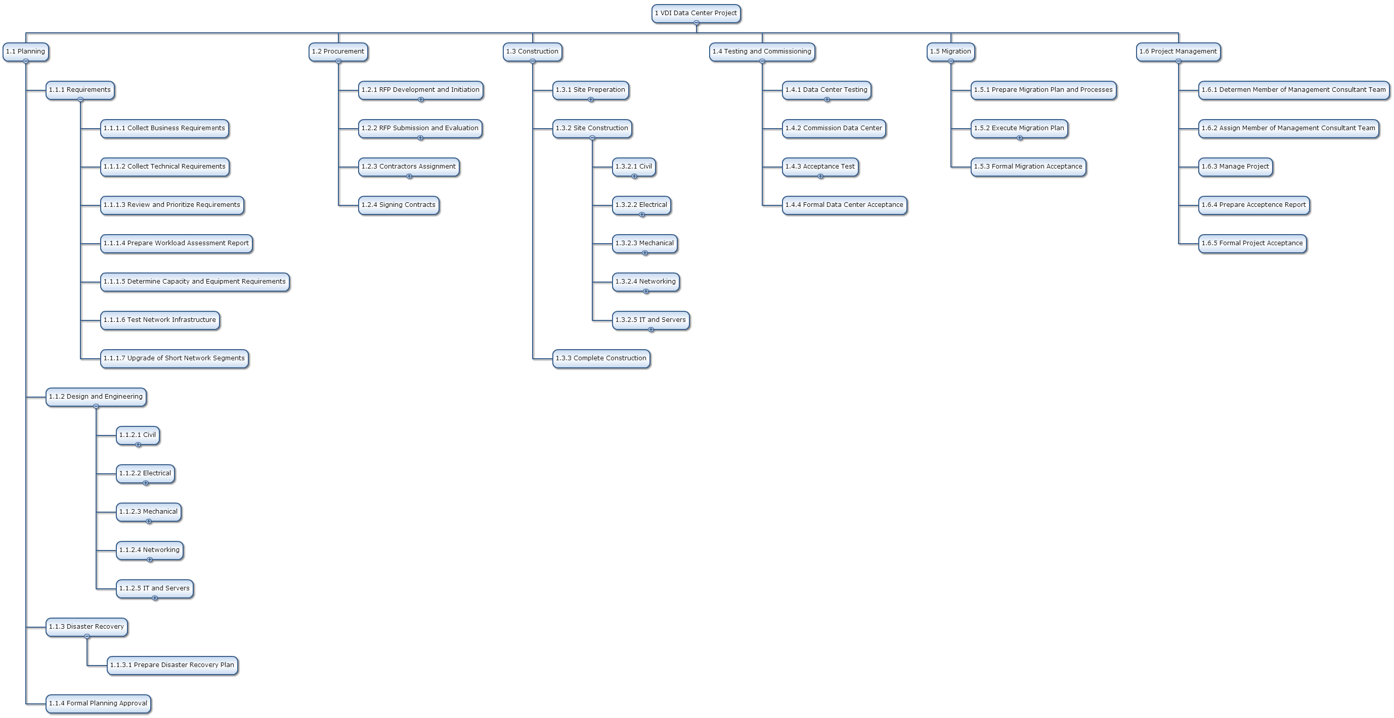
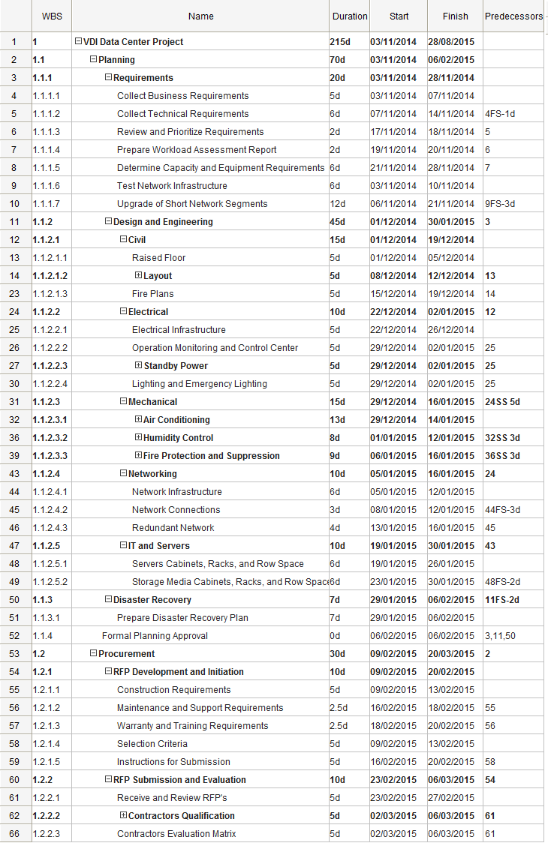
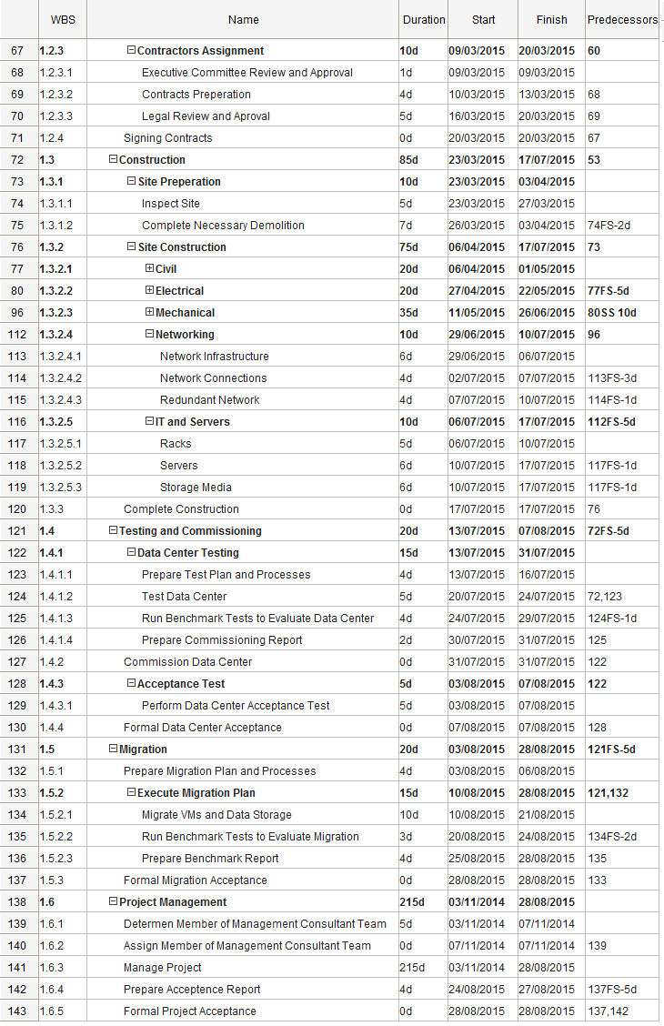

Schedule Gantt Chart
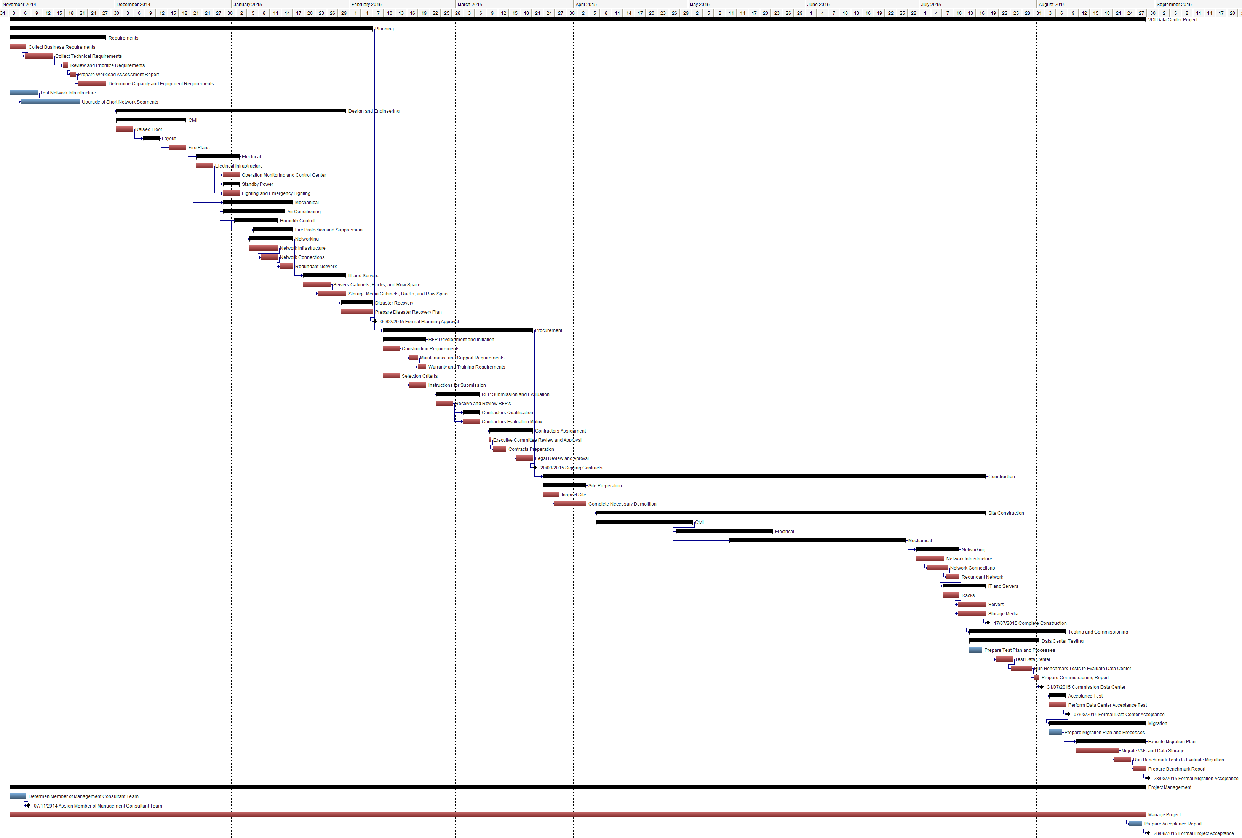

Risk Register

Risk | Probability | Impact | Mitigation Strategy
Project cost exceeds assigned budget | 4. Very Low | 1. Severe | Management Reserve will be used to avoid major impact. Initial capacity of servers will be reduced if Management Reserve did not cover extra cost, provided that structural and technical design will be kept fully scalable.
Design faults due to capacity or reliability of power, cooling, or fire suppression systems | 4. Very Low | 1. Severe | Power, cooling, and fire suppression designs and implementation will be contracted to vendors with solid business record. A management consultant team will be closely monitoring quality of external vendors and assure they meeting or exceed project minimum requirements.
CoC Corporate Security delay in tasks require their approval or interference | 1. High | 2. Significant | Work closely with CoC Corporate Security to keep them updated about tasks that require their interference. Get their approval about these tasks beforehand to prevent any delay of project implementation.
CoC ITServices resources and staff not available according to schedule | 2. Medium | 2. Significant | Work closely with CoC ITServices to keep updated about their recourses and staff availability. Add external recourses when CoC ITServices are not available for tasks on critical path.
Migration of critical business units interrupt their critical operations | 2. Medium | 2. Significant | Implement the Migration Strategy plan and closely monitor the migration process until completed and tested successfully both by the technical team and the business unit personnel.
Project site is not handed over on scheduled time | 3. Low | 2. Significant | Inform CoC that delay in handing over project site will impact overall schedule. Fast Track project schedule when possible to reduce impact and Crash project schedule if resources are available to meet deadline.
Delay in RFP process | 3. Low | 2. Significant | Closely monitor RFP process to prevent any major delay in reviewing and selecting vendors and contractors.
Present network infrastructure does not meet minimum requirement for operation of the VDI-DC | 3. Low | 2. Significant | Fully inspect CoC network infrastructure connect to the VDI-DC site and assess its capacity. Immediately report any shortage of capacity and request crash upgrade of short segments.
Flood | 4. Very Low | 2. Significant | Implementation will be significantly impacted by flood and there is very little that can be done about that. However, structural and technical implementation of the VDI-DC is going to be based on flood resistant designs as the operation of the data center is require to continue in case of flood hits the city for critical business unit to efficiently work and operate at such times. The management consultant team will monitor implementation of designs to assure they meet requirements for flood resistance.
CoC delay in moving equipment provided by them to be used at the VDI-DC | 3. Low | 3. Moderate | Inform CoC Corporate Assets about equipment move tasks that are required to be completed by them. Follow up with them to make sure tasks are completed according to schedule agreed upon.
CoC delay in moving furniture provided by them to be used at the VDI-DC | 3. Low | 4. Minor | Inform CoC Corporate Assets about furniture move tasks that are required to be completed by them. Follow up with them to make sure tasks are completed according to schedule agreed upon.

Site Selection Criteria Checklist

Item | Item | Yes | PAR | NO | N/A | Comments
1 | Are there low risks from environmental threats such as:
1.1 | Aircraft traffic?
1.2 | Earthquakes?
1.3 | Floods?
1.4 | Hurricanes or tornados?
1.5 | Heavy ice or snow?
1.6 | Nearby hazardous industry?
1.7 | High crime rate?
2 | Are there secure utility service entries?
3 | Does the site have the ability to limit or restrict physical access to the data center?
4 | Is hard water a potential problem?
5 | Are multiple-grid commercial power services available?
6 | Are there data/voice communications nearby and capable of supporting requirements?
7 | Is there public transportation available nearby?
8 | Is there adequate parking available?
9 | Is the parking area physically separated from the building by barriers?
10 | Is the labor market adequate to support requirements?
11 | Is the loading dock access at truck bed height?
12 | Are there ramps for loading dock?
13 | Are there local ordinance restricting truck/delivery traffic?
14 | Is loading dock and staging area secure and segregated from sensitive areas?

To use the selection criteria checklist table, check off the appropriate columns for each item as they are assessed. Columns are recorded using the following:
- Yes – the site fully conforms.
- PAR – Partial conformity.
NOTE: If a partial conformity exists, an explanation describing the partial conformity along with planned actions to remediate should be entered in the comments field.
- No – Does not conform.
NOTE: If a non-conformity exists describe the non-conformity and if any action to remediate is planned. Also note where no remediation is possible.
- N/A – Not applicable

